Software Design Documentation
for
Unicalc
Version 1.0 approved
Prepared by John Reese
Ben Greenwood
Alek Demko
Universal Design
4/13/07
Table of Contents
1. Introduction 1
1.1 Design Overview 1
1.2 Special Notes 1
1. Accessibility Libraries 2
2.1 Qt 2
3. Class Diagram 3

Revision History
Name | Date | Reason For Changes | Version
John Reese | 4/13/07 | Initial Version | 1.0

1. Introduction
The Unicalc calculator was designed to be a cross platform application written using the Qt Open Source Edition widget set. It is required to be primarily accessible to the visually impaired and hard of hearing, and as such, will employ multiple methods of conveying information to the user. For convenience of testing during development and possible alternate methods of input, a Lua script interpreter will be integrated in such a way that scripts will be able to directly manipulate the graphical interface.

1.1 Design Overview
The primary interface for Unicalc will be built from standard Qt widgets, with the standard menu and a grid of push buttons and text boxes comprising the whole of user interface. The interface will be implemented in the primary application class, and will use standard Qt actions to send signals from the buttons and menu items. The interface will receive signals from the math engine for any errors or state change, and initiate proper user feedback, such as error beeps or updating the text boxes. If the project scope later increases to include more functionality than that of a simple four-function calculator, then it may be appropriate to further abstract the interface objects from the main application logic, but for simplicity and rapid development, they will stay combined as a single class.
A separate math engine class will contain the calculation state and math logic, and will receive signals from the graphical interface, and alter the state appropriately. If any input signals are deemed inappropriate for the current state of calculations, the input will be ignored, and an error signal will be sent to the graphical interface. For all correct input, the state will change, and a signal will be sent to the interface to update it. Due to the signals and slots architecture of Qt, the math engine can be completely independent of the interface, and the design can be scaled to include any extra functionality that may be needed in the future. This also means that a different interface can be remotely attached to the math engine without any changes.
The final piece of Unicalc is the Lua interpreter, which will also be a separate object from the interface, much like the math engine. It will maintain the state object for the interpreter, and be able to read .lua files from disk and execute them in the interpreter. For simplicity in the first release of Unicalc, and because users are not expected to be using the feature, the Lua interpreter will use the standard operating system file chooser. A static class object will contain functions that can be called from the Lua virtual machine, which will allow the Lua script to manipulate the graphical interface in the same manner as a unimpaired user would, by directly "clicking" the buttons. This will allow automated testing of Unicalc's interface without requiring the use of external tools.

1.2 Special Notes
The initial design is highly simplified, and combines many elements that would be preferably be separated in a more complex project. However, many pieces have been combined or have hardcoded portions to aide rapid development and to focus on the actual methods of making the application accessible. If an extended development plan were to be put in place, an application-wide refactoring process is highly recommended to limit or remove coupling where possible, and to allow for better abstraction and further feature expansion.

2. Accessibility Libraries
The Qt widget set has a built-in method of making an application accessible to outside tools and AT clients, and that will be the preferred method of general accessibility. However, the planned text-to-speech will require use of a separate library, as Qt has limited sound capabilities. This may prove difficult for a cross-platform application, and no suitable text-to-speech engine has yet been selected.

2.1 Qt
The preferred method of generating an AT client accessible Qt application is by wrapping all graphical interface objects with a generic accessibility class. This class (QAccessibleInterface) provides the appropriate properties for screen readers and other accessibility tools to gather information from and interact with the graphical interface. Unfortunately, no pre-wrapped versions of the standard Qt widget set exist, so Unicalc will need to implement it's own wrapped versions of any interface objects it may use, including menu items, push buttons, and text boxes.
Audible cues for visually impaired users can be generated with the limited set of sound operations supported by Qt. A range of clicks and bells will be used to offer both positive and negative feedback to the user, and can simply be played automatically by connecting signals sent from the interface actions to a sound server. Visual cues for hearing-impaired users can also be generated by the Qt library. A simple screen flash can be used to simulate error bells, and a status bar icon can be created and altered to give positive and negative similar to the audible cues.

3. Class Diagram
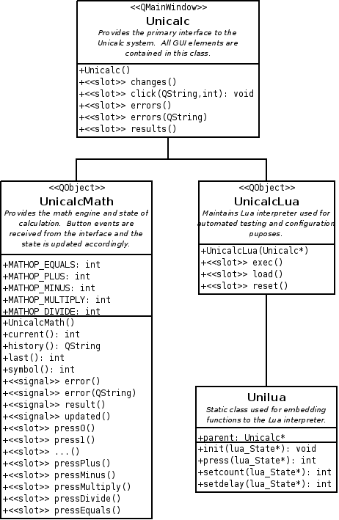
This class diagram represents the very basic structure of the Unicalc application, including only the core application logic without the use of accessibility content. All accessibility features will either be part if the primary application object, or will act as an independent module, similar to the math engine or Lua interpreter. This diagram will be updated when a final decision has been made on the use of a text-to-speech module, and if any changes are made to the fundamental design of the system.

